Sarasota Green Building Policy - Policy Considerations to Date
This document details green building policy recommendations for the City of Sarasota. To develop these recommendations, the City, in conjunction with Southface Institute and Greenlink Analytics reviewed a series of potential policies identified in the City’s request for proposal document, along with additional materials provided by the City and best practices from similarly situated cities.

Building Performance Standard (BPS) Phase 1
BPS phase 1 measures a building’s energy and water performance over time against similar building nationally, to arrive at a relative score. The data is reported to the city and helps create a more transparent market for users and resident of the building. This will be adopted by a phased in approach over the next 5 years and will start with larger buildings first and expand to buildings with smaller footprints second.

Sector Affected: Commercial/ Existing Buildings larger than 25,000 ft sq
- ENERGY STAR Portfolio Manager is the nationally recognized standard and widely used tool for tracking building energy performance
- Many building management teams already utilize ENERGY STAR Portfolio Manager
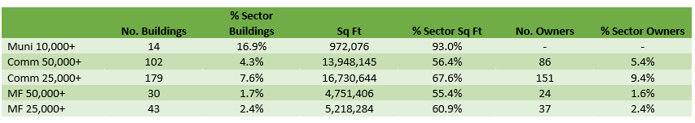
- Reporting provides City staff with full picture of energy consumption in its commercial building stock, identifying information essential for drafting policies and programs to drive energy savings in buildings for the future

Building Performance Standard Phase 2
Sets building energy performance improvement targets for existing buildings to reduce carbon emissions
Sector Affected: Commercial/ Existing Buildings

- BPS standards are set and informed using energy data
- Efficiency requirements can be set through a prescribed energy use intensity or ENERGY STAR score
- Multiple standards can target different sizes and types and building performance thereby avoiding undue financial impacts
- Requires buildings to achieve performance improvements by specific dates relative to their tracked performance
- BPS is best implemented after many years of good data collection.

Time of Lease + Time of Sale Energy Performance Disclosure
Requires owners of commercial and/or residential buildings to provide energy performance data at the time of lease and time of sale
Sector Affected: Residential/Commercial- Existing Buildings of all sizes

- Disclosures may come in the form of an ENERGY STAR score, Home Energy Rating System (HERS) rating, or other metric that informs potential future renters and owners of the building’s energy and performance
- Creates market transparency for total cost of building operations
- Builds on energy disclosure system already present in residential real estate transactions

